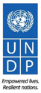

Quarter 2 2018 Report for Kreditanstalt für Wiederaufbau (KFW)
Funding Facility for Stabilization (FFS)
June 2018

Objective: This quarterly progress report provides an overview of activities funded by KfW under the BMZ Agreements 2017-40-836, 2016-18-644, 2017-18-626, and 2017-49-944. Agreements 2016-18-644 and 2017-40-836 are joint agreements between UNDP’s Funding Facility for Immediate Stabilization (FFIS) and the Iraq Crisis Response and Resilience Program (ICRRP) and KfW. The sections on these Agreements below corresponds with FFIS Outputs; ICRRP Outputs are reported in a complementary document, and will be combined in future reporting. The overview enables KfW to ascertain the activities undertaken during the reporting period, issues that may have arisen, and a brief financial summary.

Budget Overview: UNDP’s financial management system does not differentiate between agreements based on the donor’s identifiers. As such, the financial information in Annex I provides a costing of each of the completed projects and below provides a general overview. These were manually identified and organized by the agreement number. As per the Financial Arrangements, official UNDP financial reporting is provided only from the Certified Financial Reports which are released every June for the previous calendar year by donor and UNDP project. Further, for those projects that are not yet completed, activity budgets are subject to change. Changes may arise due to variation orders or extensions of projects. Only upon completion of projects and delivery of payments are figures final. Nonetheless, only UNDP Certified Financial Reports comprise official reporting.

The following is an informal financial summary for FFIS components of the Agreements:

Agreement | Total Amount  (Euro) | Total Amount  (USD) | Received So far  (USD) | Approx. Committed/Spent (USD)
201618644 | 10,500,000 | 11,432,663 | 11,432,663 | 10,261,995
201749944 | 29,300,000 | 34,551,887 | 13,270,142 | 0
201718626 | 40,000,000 | 46,457,608 | 29,036,005 | 0
201740836 | 30,000,000 | 35,332,617 | 16,362,028 | 10,057,760.15
Total | 109,800,000 | 127,774,775 | 70,100,838 | 20,319,755.10

The following is an informal financial summary for ICRRP components of the Agreements:

Agreement | Total Amount  (Euro) | Estimated Budget (USD) | Received So far  (USD) | Committed  (USD) | Expenditure  (USD) | Utilized (USD)
2017-40836 | 10,000,000 | 12,293,013 | 5,454,009 | 3,749,727.03 | 62,426.24 | 3,812,153.27
201618644 | 29,500,000 | 33,146,068 | 24,923,057 | 8,917,664.18 | 8,098,120.10 | 17,015,784.28
Total | 39,500,000 | 45,439,081 | 30,377,066 | 12,667,391.21 | 8,160,546.34 | 20,827,937.55

FFS Program Context:

In response to the crisis in Iraq the Funding Facility for Immediate Stabilization (FFIS) was established in June 2015. FFIS is organized in four ‘windows’ to support four types of activities: 1) Window One: Public Works and Light Infrastructure Rehabilitation; 2) Window Two: Livelihoods; 3) Window Three: Capacity Support, and 4) Window Four: Community Reconciliation. All activities are be decided in agreement with the Provincial Council and Governor, based on priorities identified at the local level through consultations. Given the sensitive nature of stabilization and the fragile conditions prevailing in many newly liberated areas, concerns relating to human rights, protection, gender and inclusion are considered during the prioritization and sequencing of activities.

When FFIS was established, the working assumption was that longer-term stabilization projects would be undertaken by the Government using public revenues as FFIS left a city or district. This sequencing has not materialized due to the drastic drop in oil revenue. Therefore, in April 2016 a second channel of the Funding Facility was opened for meeting the ‘expanded’ needs at Governorate level for larger projects (over USD 2 million) of a longer period (between two and three years duration). It has been named the Funding Facility for Expanded Stabilization (FFES).

Together FFIS and FFES comprise the Funding Facility for Stabilization (FFS) and share the same management and Steering Committee. The channels are ways by which contributing nations can support different phases of the stabilization process and helps UNDP and the Government of Iraq sequence interventions. However, management, implementation, and oversight of FFES and FFIS is the same, as is the project selection process.

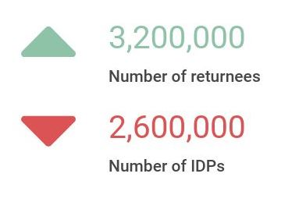
Despite the devastating impact of the war on the Iraqi people, 2017 represented a crucial year in the Iraq displacement crisis in that, for the first time since the beginning of the crisis, the International Organization for Migration’s (IOM) Displacement Tracking Matrix has recorded more returnees (3.2 million individuals) than Internally Displaced Persons (IDPs) (2.6 million individuals) across the country.

The trends are promising; however, much work remains to be done to ensure the 2.6 million displaced persons can return home. This is particularly true in five critical areas: western Ninewah, Mosul, the Baiji-Hatra corridor, Hawija and its environs, and western Anbar. These areas were the last to be liberated and some of the first areas to fall under ISIL control in 2014. In order to succeed in the stabilization of these areas it is imperative moving forward in 2018 that it be recognized that some of the areas that are most vulnerable to the re-emergence of violent extremism, typically those areas which were last to be liberated, are the ones that are most critically underfunded.
For the first time, IOM has recorded a higher number of returnees than IDPs, marking a crucial year in the history of the Iraqi conflict

A significant number of KfW funded projects are clustered in East and West Mosul. While close in geographical proximity, the trends regarding returns are inherently different in the two parts of the city. While IOM doesn’t offer data dissagregated between East and West Mosul, overall, as of 15 June, 849,126 people have returned to the Mosul area. East Mosul, liberated in Q1 of 2017, was increasingly accessible to FFS teams over the course of last year. Unlike other major liberated cities, there was no lag time between liberation and the return of IDPs: in most cases, IDPs had left only during the battle begun in September 2016 and returned soon after liberation. As such, speed was an imperative above all previous FFS operations. West Mosul, on the other hand, approaching the one year anniveristy of its liberation (July 2017), remains accessible, but work is challenging due to ongoing IED and explosive hazard threats. Just as these are threatening for FFS staff and contractors, they also inhibit the return of IDPs to the Western portion of the city.
Overall, the strategic partnership with UNMAS has been incredibly important to facilitate FFS work. UNMAS and its partners have trained hundreds of cash for work beneficiaries and cleared over 400 worksites (in East and West Mosul) of hundreds of explosive devices, including IEDs, suicide vests, unexploded ordnance, mortars and grenades. Despite this work, many explosive devices remain hidden under the rubble, particularly in West Mosul, and engineering teams undertake their work as carefully as possible.

Agreement BMZ No. 201740836

Overview: Agreement 2017-40-836 was a joint agreement between two programs in UNDP (Iraq Crisis Response and Resilience Program and the Funding Facility for Immediate Stabilization) and KfW for a total contribution of EUR 40 million. Activities for all four outputs are to be completed by 1 July 2020. The aim of the Agreement is to create income-generating opportunities for returnees in Mosul and IDPs affected by the Mosul operations. Each job created should last for at least two to three months and meet the criteria established under BMZ Pathways for Partnerships initiative. This section below provides an overview of FFIS Output 1; ICRRP reporting is complementary to this report, and will be joined in the future.

FFIS Output 1 – Rubble removal and public space rehabilitation in Mosul through cash for work schemes

Indicators:
  - # of individuals employed through cash for work schemes in Mosul
  - # of labor of days
  - # of direct and indirect beneficiaries in Mosul (assuming household size of 5.5)
Targets:
  - 14,126 individuals employed through cash for work schemes (6,528 individuals in 2017; 5,124 individuals in 2018; and 2,474 individuals in 2019)
  - 889,964 labor days
  - 78,000 individuals in Mosul
Cumulative Progress as of Q2 2018:
  - 5,135 individuals employed through cash for work schemes (including workers, work monitors and field monitors); 1052 are women.
  - 308,100 labor days (each individual engaged deployed on average for 60 days)
  - 30,810 individuals in Mosul directly and indirectly benefit

Project name | Status | # of workers | Women | Men | # of work monitors | # of field monitors
West Mosul General Hospital | Completed | 60 | 15 | 45 | 3 | 2
Al-Jadeeda | Completed | 200 | 40 | 160 | 5 | 6
Ninewah University | Completed | 40 | 11 | 29 | 2 | 2
Clean up Soq Al Mosul shehk Abo Al Ola 2 Neighborhoods in the west Mosul | Completed | 150 | 0 | 150 | 3 | 5
Clean up of Naby Gargeas and Shekh Abo A-Ola 3 Neighborhoods in the old city -West Mosul | Completed | 150 | 0 | 150 | 3 | 5
Al -Ghizlani Clean up Project -West Mosul, Ninawa Governorate Lot 1-Al-Jawasaq & Al-Tayaran Neighborhoods | Completed | 300 | 50 | 250 | 5 | 10
Al -Ghizlani Clean up Project -West Mosul,Ninawa Governorate Lot 2-Dandan, AlDawasa&Naby Sheet Neighborehoods | Ongoing | 350 | 70 | 280 | 7 | 12
Al -Ghizlani Clean up Project -West Mosul,Ninawa Governorate Lot 3-Al Okaidat& Bab Agaded Neighborhoods | Completed | 300 | 60 | 240 | 5 | 10
Al-Rabee, Lot 1: Misherfa 1, Misherfa 2, 17 Tamuz , 30 Tamuz, Al Eqtisadiean | Ongoing | 300 | 50 | 250 | 6 | 10
Al-Rabee, Lot 4: Hay Al Maamel, Yarmok, Nahrawan | Completed | 300 | 60 | 240 | 6 | 10
Clean Up Qatheb AlBan And Meshahda Neighborhoods/ West Mosul | Ongoing | 150 | 0 | 150 | 3 | 5
Clean Up Khatoniya And Ahmadeya Neighborhoods - West Mosul | Ongoing | 150 | 0 | 150 | 3 | 4
Clean-up Project of Hospital Complex Lot 1 (Al-Batool maternity hospital, Infertility center, X-ray institute, Burns Unit) | Completed | 200 | 143 | 57 | 5 | 5
Clean-up Project of Hospital Complex Lot 2 (Blood Bank Building, Internal Streets and all courtyards) | Completed | 200 | 50 | 150 | 5 | 4
Al-Zuhoor (Lot 3) | Completed | 300 | 36 | 264 | 10 | 10
Al-Zuhoor (Lot 4) | Completed | 300 | 45 | 255 | 10 | 10
Al-Zuhoor (Lot 5) | Completed | 300 | 25 | 275 | 10 | 10
Nerkal | Completed | 700 | 161 | 539 | 16 | 11
Mosul Technical College and Technical Institute clean up project Ninawa Governorate Iraq | Completed | 250 | 100 | 150 | 8 | 7
Clean-up of Mosul University/East Mosul | Ongoing | 150 | 120 | 30 | 5 | 5
Cash For Work - Repairs of Kokjely Schools Desks | Completed | 20 | 16 | 4 | 2
Total for reporting period | 21 projects | 4870 | 1052 | 3818 | 122 | 143

Rubble removal and cash for work remains one of the highest priorities of Ninewah and Mosul authorities, especially in West Mosul. As such, the first cash for work projects in West Mosul were started in the fourth quarter of 2017 thanks to the KfW contribution, and continued into Q1 and Q2 of 2018. The initial phases of cash for work operations focuses on clearing debris and rubble of streets, alleyways, and public buildings in significantly damaged areas of West Mosul, as prioritized by the local authorities. By the close of the reporting period, FFS had created job opportunites for 5,135 workers with KfW funding. This included 1052 women workers. Continuing from the work undertaken during Q1, cash for work projects have continued to employ local people to clear streets, medical facilities, and buildings (funded by KfW) through twenty one projects.

WEST MOSUL

Notably, four cash for work projects have been completed during the reporting period. These four projects where significant employers while being implemented; employing a total of 1100 people, including 303 women. The projects also employed an additional 21 work monitors and 30 field monitors.

As is detailed below, these projects cleared many streets, alleyways, and even shops. In essense, these projects, along with other ongoing and upcoming FFS cash for work projects, cleared the way for life to begin to begin to return to West Mosul. As reported during Q1, the intention of the cash for work projects is to improve accessibility and maneuverability throughout neighborhoods and public spaces so that returns can begin, as well as create income-generating opportunities. Indeed, cash for work projects have been successful in clearing streets, which, in turn, have allowed IDPs accessed to their homes which were previsouly inaccessible due to rubble (see FFS Impact Story, Box 1). The work has also cleared the way for some shop owners in the Old City to prepare to reopen them. Overall, these projects are not only creating much needs opportunities for livelihood generation but also are working to clear previously impassable streets so people can return to their homes. While there are no reliable figures as of yet, with ongoing KfW funded cash for work operations providing job opportunities and clearing rubble so businesses can re-open and people can access their homes, FFS anticipates more and more returns to West Mosul.

The feedback from beneficiaries has been very positive across East and West Mosul, and there continues to be high demand for such support from both the returnees and local authorities. Beneficiaries interviewed by FFS following completion of a project consistently ask for future work opportunities, and indicate that there remains a significant need to generate income in order to return home.

Box One: FFS Impact: Restoring life to West Mosul, clearing streets and creating job opportunities
Mr.Abdul Salam Yahia Qasem, 70, stands outside his home in the Old City of Mosul. In January 2018, the FFS team spoke with Abdul and he described how he and his family left their home when ISIL took control of the city. Despite the city now being liberated from ISIL control, they have been unable to return home as the street leading to their house was covered with rubble from neighboring houses that were hit by airstrikes. Following the removal of rubble by KfW funded cash for work crews from Abdul’s stree,t he and his family where finally able to access their home and begin assessing the damage.
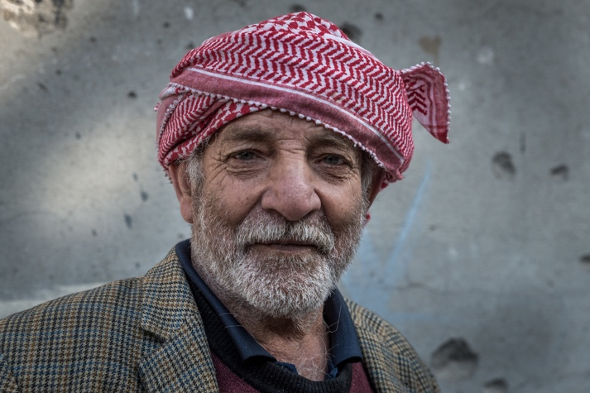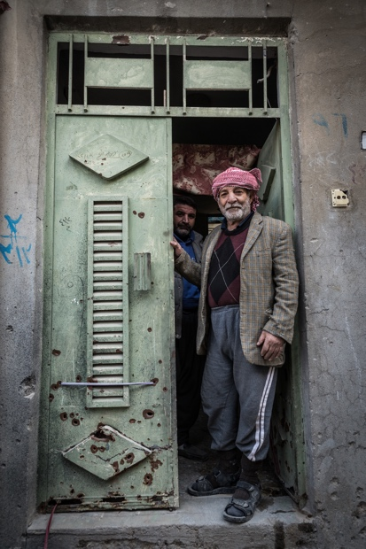
Abdul Salam Yahia Qasem stands outside his home in the Old City of Mosul. ©UNDP Iraq/Claire Thomas
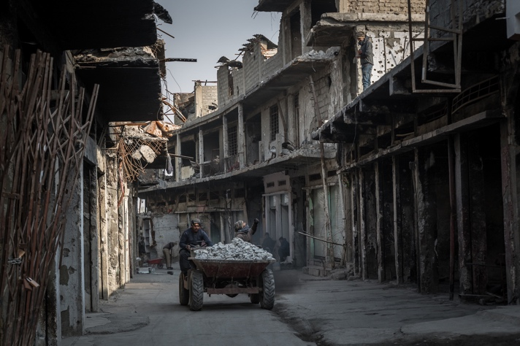
KfW funded FFS cash for work teams have worked tirelessly to clear rubble from the streets, allowing West Mosulawis access to their homes. ©UNDP Iraq/Claire Thomas

This is not to say that this work does not come without risk. Desipte the rigorous site clearance that is undertaken by UNMAS, the work is also dangerous. The Old City is deemed extremely high risk for IEDs and explosive hazards (see challenges section below). UNMAS and its partners have trained (at no cost to KfW) 2,596 cash for work beneficiaries (in East and West Mosul) to be aware of the of hundreds of explosive devices, including IEDs, suicide vests, unexploded ordnance, mortars and grenades. Despite this, devices remain hidden under the multi-level rubble of West Mosul’s buildings, and FFS teams must undertake the clearing work as carefully and as vigilantly as possible.

Completed projects:
Four KfW funded CfW projects were completed during the reporting period:
- Rubble removal in Rabee Area, Lot 4 completed
The Lot 4 rubble removel project in the Rabee area was completed in May 2018, after employing 306 workers, including 60 women, for 75 days. Following the completion of the project, the sites where checked by UNDP engineers and members of the Livelihoods team, who confirmed that streets, alleyways and sidewalks had beeb cleared of both rubble and also of car wreaks, which were blocking significant portions of the useable space.
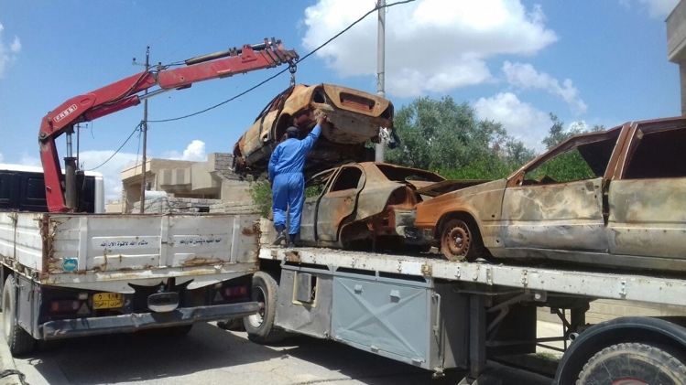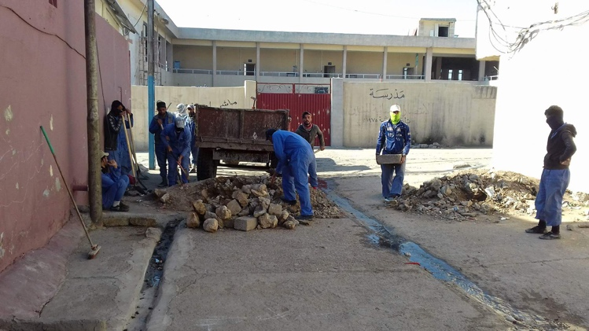
Ongoing rubble, debris removal and car wrecks removal in Rabee 4/ West Mosul
- Rubble removal, Hospital Complex, Lot 2 completed
All work in the Al Shifaa Hospital Complex Lot 1 was completed by the end of May, 2018. Some of the work, such as in the Al-Batool Maternity Hospital, the fertility clinic and the X-Ray building was completed in early Q2, whereas other components of the project, such as the clearing of the Engineering Department and Dental Clinic Building and the Emergency Room unit were finished in the latter part of the reporting period.
This project was particularly noteable due to the high proportion of women engaged in the project. In total, 143 women and 57 men were employed to undertake the work. Similar to other CfW projects in West Mosul, the work was comprised of rubble and debris removal in the specficied areas as well as the removal of car wrecks which were inside the hospital complex.
The importance of this CfW project cannot be understated, and the livelihoods team gave it due attention by visiting at least once, sometimes twice, a week. The al-Shifaa complex used to be one of the most renowned hospital complexes in the country but was extremely badly damaged, having functioned as one of ISIL’s last headquarters in Mosul. Even in normal curcumstances, the renovation of medical facilities is a complex thing to do, involving decisions to reorient facilities towards particular areas of specialization and ensuring that provision is made for the most up-to-date forms of care. The existance of heavy rubble would make the rehabilitation of the facility even more daunting. However, with the completion of Lot 2 of rubble clearance, the facility is more accessible and much better prepared for the engineering teams (not KfW funded) which will be undertaking its overall rehabilitation.

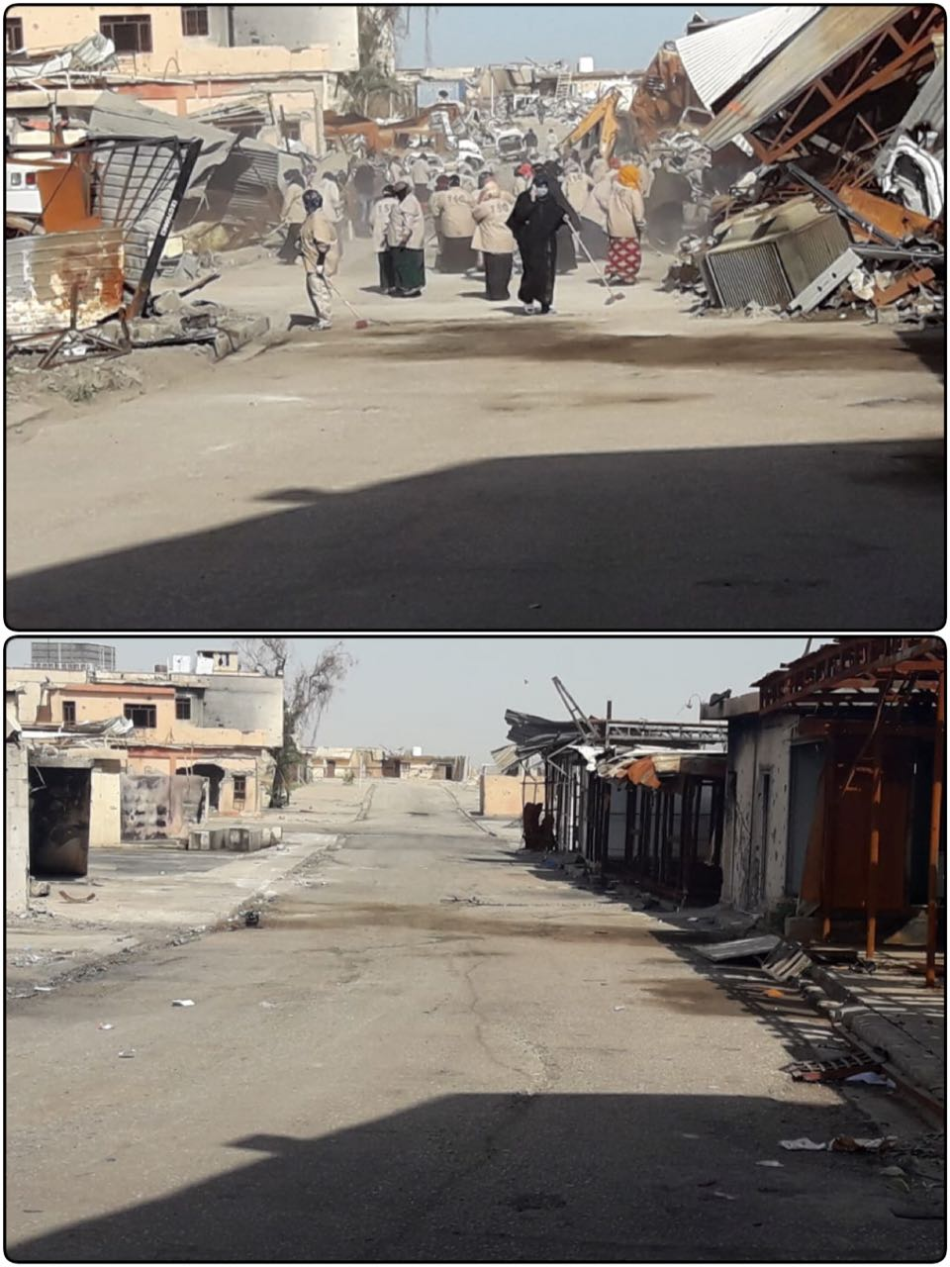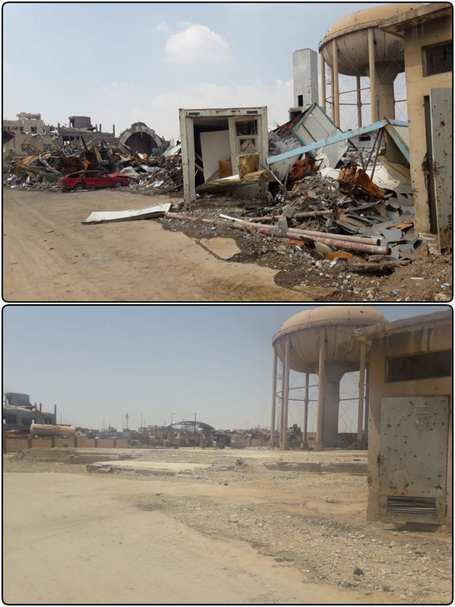

Before and after photos for CfW crews and rubble removal from the Hospital Complex

Before and after photos for CfW crews and rubble removal from the Hospital Complex
- Rubble removal in Qatheab Al-Ban and Al-Mshahda completed
The rubble removal project in Qatheab Al-Ban and Al-Mshahda was completed during the first week of June. Through its duration, the project employed 150 workers, 3 work monitors and 4 field monitors. Upon completion, work was inspected by UNDP’s Liasion Officers and engineers who found that all streets, alleyways and sidewalks had been cleared.
- Rubble removal in Rabee area, Lot 1 completed
The clearing of rubble in Lot 1 of the Rabee Area was a significantly sized project that employed 300 workers, including 50 women, as well as 6 work monitors. The project was concluded during the reporting period.The project is implemented in coordination with municipality and was closely supervised by the UNDP Livelihoods team. On numerous occainsions, CfW workers were asked by sectoruty forces to clear areas outside of the deliniated CfW area. In some cases, these requests were approved, and UNDP sent workers to clear areas for durations of 2-3 days. Finally, 500 garbage containers and 5 tons of garbage bags were distributed during the last days of the project ito schools, hospitals and other public facilities. Once completed, the project was successful at clearing rubble from streets and alleyways, and provided cleaner, safer spaces for IDPs to return to.
Ongoing projects:
There was one ongoing rubble removal project in West Mosul during the reporting period, in the Khatuniya and Ahmadiaya neighborhoods of the Old City. The project is currently 67% completed and is employed 153 workers for 45 days. Work is expected to be completed during Q3. The Livelihoods team undertook a mission to the site in May, and noticed the positive progress, noting particularly that many alleyways and the main street of Khatuniya were already cleared from rubble. Also notable during the reporting period was an informal partnership which was struck between UNDP CfW teams and a voluntary group (Yad Al-Awn for Hadba’a) which was working in the same area, helping people to remove rubble from their own houses. After the UNDP Livelihoods team met with the voluntary group and made clear that CfW workers were not mandated to clean inside people’s homes, the two groups agreed that the voluntary group would continue supporting the inside cleaning of homes, placing the rubble outside on the street, and UNDP CfW workers would follow, clearing the rubble already on the streets and also the rubble that had been cleared inside houses. Postive partnerships such as this one give immense hope that work that is being undertaken in the Khatuniya and Ahmadiaya neighborhoods, and more broadly in West Mosul, will ultimately mean cummunities can be restored to neighborhoods and homes.
Projects in development:
Project preparation is well underway in West Mosul, particularly the four projects in Rabee Lot 5 and Al Ghizlani Lot 2.
The rubble removal of Rabee’ Lot 5 will create 250 job opportunities, of which 70 women for 75 working days and is expected to begin in early Q3. A kick-off meeting with the contractor to define the plan and to go over procedures was already held during Q2. Moreover, 150 of the workers were provided with Explosive Hazard training in June. Finally, eight field monitors have been appointed and an orientation on how to monitor the project and how to report issues will be undertaken with the monitors imminently.
The selected company has already prepared the list of workers who have been chosen from Ghizlani area in preparation for the beginning of work in Al Ghizlani, Lot 2. Explosive Hazard training for workers and field monitors was conducted in June for 350 workers with 12 field monitors. Finally, the 12 field monitors for the rubble removal project in Al Ghizlani, Lot 2 have participated in the orientation session on monitoring of CfW projects, which was conducted in early June.
For both projects, in Rabee Lot 5 and Al Ghizlani Lot 2, preparations are being finalized and work should begin in early Q3.

EAST MOSUL

At the end of the reporting period, there was 18 CfW projects in East Mosul, 17 of which had been completed, and one which was under implementation.

The rubble removal at Mosul Technical College was completed during the reporting period. The project provided job opportunities for 250 workers, of which 100 were women, for 60 working days, where all the buildings, workshops, streets, gardens and annexes to the Technical College and Technical Institute were cleaned from rubble even those outside the campus. The site(s) was received by the College Administration at the beginning of June.. As reported during Q1, the project at the Mosul Technical College and Technical Institute demonstrated an important milestone in clean-up projects conducted by FFS: 80 percent of the 250 participants were women. Further, 80 percent of the field monitors and the Liaison Officer and Livelihoods Officer overseeing the project were all women.

The one ongoing project in East Mosul, the rubble removal project in the University of Mosul is going well. As with the completed project in the Technical College and Technical Institute, there is a similar dedication to hiring as many women as possible. Currently, 30 women are employed through the Univiersity of Mosul rubble removal project. The project is currently 55% complete. This project is a complex one, with numerous sub-projects comprising of the different buildings and colleges that make up the overall campus. At the end of the reporting period, the work on the various sites had progressed as follows: veterinary college 90%, electrical engineering college 85%, mechanical engineering lab 88%, central library 95%, university hall 80%, university entrance 70%, presidency buildings 20% street cleaning 65% and central warehouse 30%. The central library will be rehabilitated with KfW FFES funding, supporting Mosul University.

During the reporting period work on the computer science college and the computer science dean’s buildings were completed.

The Veterinary College:

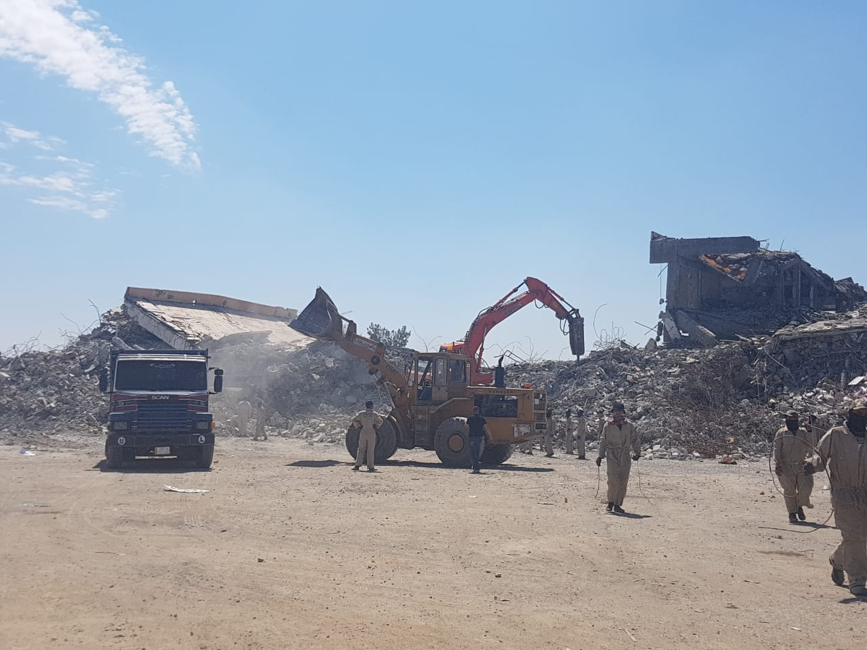
Ongoing demolishing of Veterinary College while workers are removing light weight rubble

Technical College:
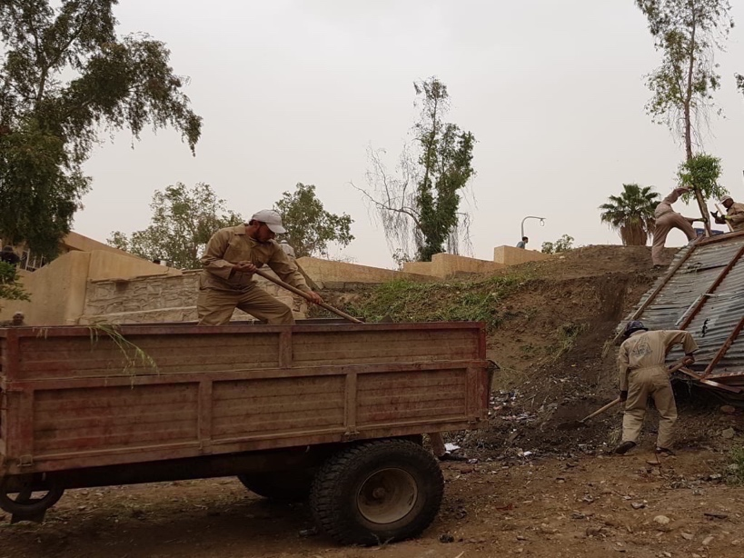

Cleaning gardens and parks works in the Technical College

The Library:
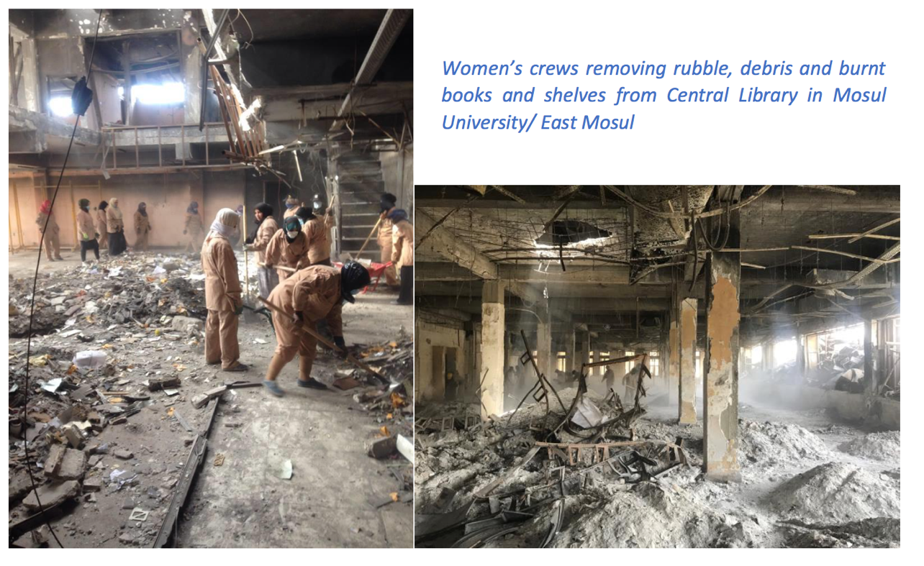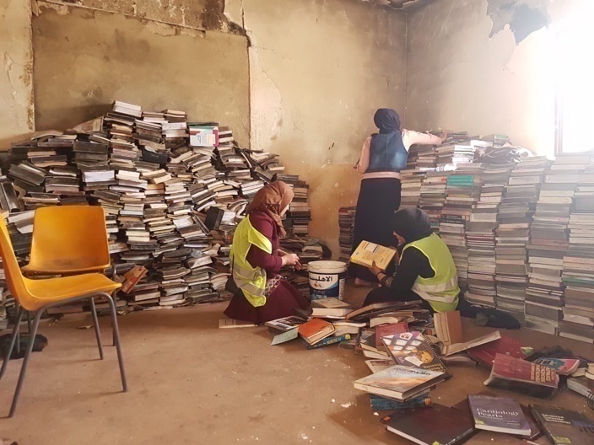

Women are cleaning books that survived from the burnt Library

Monitoring:

All cash for work projects are carefully monitored to ensure projects are implemented according to contracts and UNDP rules and regulations (See Figure One for UNDP’s livelihoods monitoring framework).

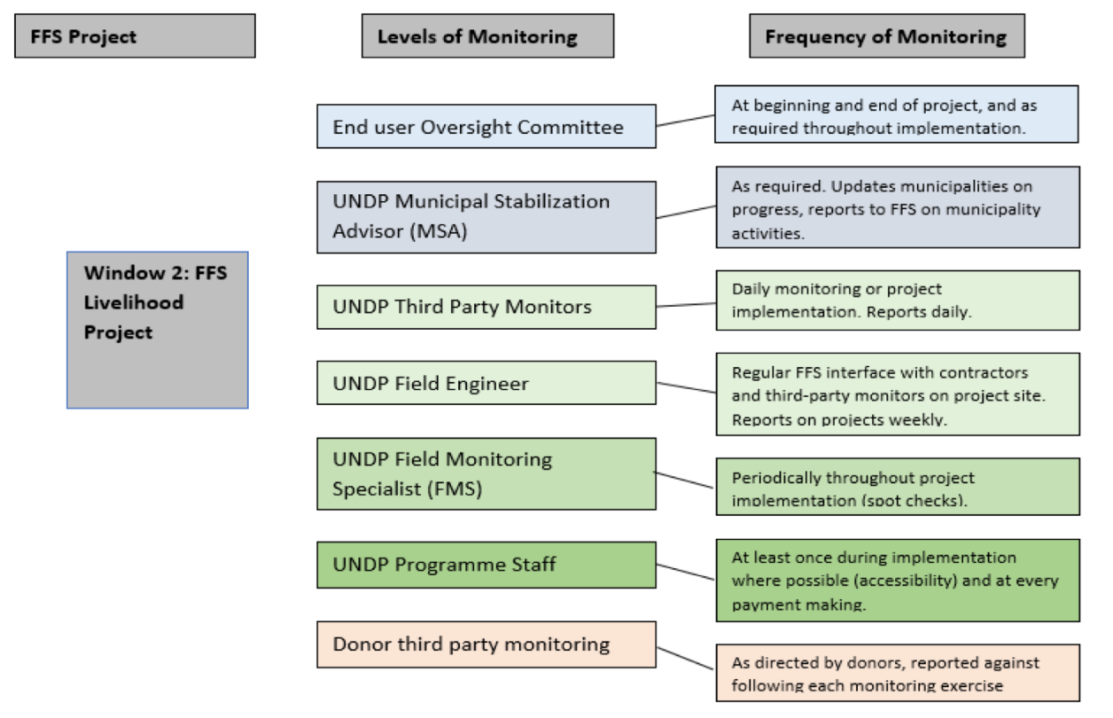
Figure One: FFS Livelihoods Monitoring Framework

Challenges:

Following significant improvements in monitoring operations and hiring of additional livelihoods staff at the end of 2017, by the end of Q2, half way through 2018, FFS is well on its way to meeting its 2018 targets. As of the end of Q2, FFS had already employed 67% of the targeted number of CfW employees for 2018. However, management of this high number of projects, as well as a significant number of individual people, does not come without its challenges.

Of note during Q2 was the tendacy for FFS cash for work teams, either the workers themselves, or their monitors, to be requested by various individuals – local citizens and/or security personal alike – to undertake work that was outside of the scope of a particularly defined CfW activity. In some senses, this is to be expected, given that not all citizens or security personnel would understand the strict dynamics under which the FFS CfW workers are employed. Consequently, teams received various requests: to clear the inside of personal residences, to clear the living quarters and headquarters of certain security personal, etc. FFS relies on its field monitors and field staff, who undergo extensive training to learn how to manage scenarios just as these, to either deal with the request on site, or, if further problems occur, to escalate the request to the Erbil-based Livelihoods Team. With the strong monitoring and reporting framework that FFS has in place from the field monitors to the Erbil-based Livelihoods team, FFS is confident that it can continue to resolve such haphazard requests and focus on the projects prioritized by Ninewa and Mosul officials.

As has been previously reported, the cash for work projects of the Livelihoods sector represent an outstandingly popular FFS programmatic area in the communities, due to its ability to provide jobs in areas where there may be few other options available, or none at all. However, due to the nature of large cash transfers, FFS considers livelihoods work as high risk for fraudulent or unethical behavior. FFS continues to rely on its revamped and stringent monitoring framework to enforce all fraud mitigation measures, including regular site visits (especially on wage distribution days in cash for work programmes), random inspections, conversations with beneficiaries, and weekly examination of written documentation. In the past, additional field staff have been recruited whose duties consist primarily, or solely, of carrying out monitoring oversight. Baghdad and Erbil-based FFS staff have continued to conduct unannounced site visits and, during the reporting period, additional Quality Assurance/Quality Control, Liaison Officers, Municipal Stabilization Advisors, and UN Volunteers support increased monitoring. While the exclusive task of these staff members is not only to conduct site monitoring, having additional staff presence in project locations has proven to help support adherence to core FFS policies around monitoring and fraud mitigation. These improvements to monitoring have significantly improved project effectiveness, as well as mitigated attempts at fraud experienced in late 2017.

As in Q1, the degree of explosive hazard and IED contamination and damage in West Mosul, namely the Old City, requires additional measures to ensure the safety of work teams. The significant degree of contamination required extensive clearance by UNMAS partners as well as conducting Basic Explosive Hazard Awareness Training by cash for work beneficiaries. The complexity of the work being undertaken by UNMAS, however, cannot be understated. During Q2, a cash for work beneficiary triggered a device, and was hospitalized with thankfully minor injuries. Discoveries such as these are undoubtedly due to the significant levels of destruction of certain sites, and the subsequent multi-level debris, which makes IED and explosive hazard clearance exceptionally difficult and only reiterate the importance of the UNMAS-UNDP partnership in Mosul, and in other parts of Iraq.

ICRRP Output 1 – Livelihoods opportunities created and key infrastructure and services strengthened

Indicators:
  - # of infrastructure projects rehabilitated
  - # cash for work opportunities created

Targets:
- Five infrastructure projects rehabilitated
- 2,535 cash for work opportunities created

Progress in Q2 2018:
  - 28 community infrastructure projects were identified in the Kurdistan Region of Iraq (KRI) to improve delivery of basic services (electricity, water, roads, education, health), and to create an estimated 1,250 cash for work opportunities.
  - 14 (out of 28) procurement processes were completed by the partner Government Institutions and verified by UNDP Engineers; 13 Letters of Agreement signed with UNDP to initiate implementation of infrastructure works, and related cash for work; 1 Letter of Agreement was in the process of being finalized during the reporting period. The signed 13 Agreements are expected to support an estimated 404 cash for work opportunities.
  - Terms of Reference developed to initiate a procurement process and identify a partner to undertake cash for work activities in Hawija (Kirkuk Governorate) creating an estimated 600 cash for work opportunities.
  - Terms of Reference being developed to for support circa 800 cash for work opportunities across 7 communities in 6 governorates, including the districts of: Mosul, Sumel, Baqubah, Khanaqin, Abu Ghraib, Mahmoudiya and Falluja. This approach will complement UNDPs Area Based Recovery efforts.

Using a labour-intensive approach, the cash for work projects will provide support to restore or construct community basic service infrastructures in host communities as well as in IDP camps/settlements to provide basic services in a sustainable and cost-effective manner. Overall, a strong community solidarity approach will be used to foster dialogue and a better understanding between IDPs and host communities. The geographic focus is the KRI which hosts most Syrian refugees and displaced people in Iraq.

In the reporting period, the originally identified 29 cash for work projects were reviewed, and 28 finalized for project support. While 13 procurement processes have been completed by Government partners, 15 are on-going and expected to be completed in July 2018. The projects aim to improve essential basic services through the construction/rehabilitation of roads, electricity and water supply networks, sewer lines and networks. A breakdown of projects per governorate is provided below:

- Six projects in Erbil- Six LoAs signed and implementation initiated.
- Ten projects in Dohuk- Seven LoAs signed and implementation initiated. One LoA is in the process of being finalized
- Eight projects in Sulaymaniyah (including Raparin and Garmian)- Procurement processes underway, and expected to be completed by early July 2018.
- Four projects in Halabja - Procurement processes underway, and expected to be completed by early July 2018.

Project Overview during Q2-2018

# | Project Name | Project Value (USD) | Status | Target Number of workers
Erbil Governorate
1 | Pave internal roads in Sarbasti quarter (Sector 32) | 209,502 | Letter of Agreement Signed; implementation initiated | 20
2 | Construction of two side roads (with the sewage system) in Farmanbaran | 238,825 | Letter of Agreement Signed; implementation initiated | 33
3 | Construction of Baharka road with street light (2.5 km length) | 914,419 | Letter of Agreement Signed; implementation initiated | 114
4 | Construction of two water wells with pump room, pumps and injector units in Naly Quarter | 167,926 | Letter of Agreement Signed; implementation initiated | 24
5 | Construction of electrical network for Shamamk sub-district | 210,408 | Letter of Agreement Signed; implementation initiated | 21
6 | Connection of the electrical network with national power grid in Krechyan Quarter, Shaqlawa District | 149,014 | Letter of Agreement Signed; implementation initiated | 17
 | Sub Total | 1,890,094 |  | 229
Dohuk Governorate
1 | Rehabilitation of the main road to Kalakchi Sub-District town | 415,435 | Letter of Agreement Signed; implementation initiated | 30
2 | Construction of international roads in Dohuk City | 177,423 | Letter of Agreement Signed; implementation initiated | 32
3 | Rehabilitation of Electricity distribution network in Shekhan District | 470,738 | Letter of Agreement Signed; implementation initiated | 38
4 | Rehabilitation of Electricity distribution network in Zakho District | 142,365 | Letter of Agreement Signed; implementation initiated | 18
5 | Extension of electricity power supply to Bijeel water project | 40,355 | Letter of Agreement Signed; implementation initiated | 6
6 | Construction of Sewer lines in West of Dohuk City | 424,902 | Letter of Agreement Signed; implementation initiated | 22
7 | Renovation of Amedi College for Basic Education, Amedi District | 91,539 | Letter of Agreement Signed; implementation initiated | 29
 | Sub Total | 1,762,757 |  | 175
 | Grand Total | 3,652,851 |  | 404

Seven Field Engineers have been recruited in Erbil, Dohuk and Sulaymaniyah to monitor and quality assure the implementation of construction work. Field Monitors will also shortly be in place to ensure close monitoring of the cash disbursement process, checking attendance list, verifying the cash payments are provided accurately and in a timely manner to the workers on site, verifying that appropriate safety equipment is being used on sites and ensuring that workers conditions of employment are satisfactory.

Furthermore to discussions with BMZ, and receiving endorsement to support cash for work activities in Hawija (Kirkuk Governorate) through this contribution, a Terms of Reference has been finalized to initiate procurement processes to identify a partner/service provider to support 600 cash for work opportunities. The procurement process is expected to be completed, and work initiated during the 3rd Quarter of 2018. Close consultations have been held with the Funding Facility for Stabilization to ensure complementarity in carrying out the cash for work activities supported by UNDP in Hawija.

Additionally, a request has been submitted to KfW through BMZ to seek approval for implementing CFW activities in a further 7 areas in which UNDP are also implementing the Area Based Recovery Approach (ABRA). UNDP has explained in its rationale for that harnessing ABRA for CFW will ensure:

- A more thorough context analysis and conflict sensitivity
- Inclusion of the local people, accounting for gender, age and vulnerable groups
- Integration of different sectoral interventions
- Stronger partnerships and coordination
- An opportunity for promoting civic engagement
- Manageability and flexibility
- Better monitoring and cost effectiveness

The adoption of this approach will further strengthen the Partnerships for Prospects (P4P) of the German Ministry of Development being implemented in Iraq.

Agreement BMZ No. 201718626

Output 1 – Expanded Stabilization projects are implemented in Mosul and Ramadi

Indicators:
  - # of expanded stabilization projects rehabilitated
Targets:
  - 1 expanded stabilization project in Ramadi (Maternity Hospital)
  - At least 1 expanded stabilization project in Mosul
Cumulative Progress in Q2 2018:
  - Ramadi Maternity Hospital tendering ongoing during Q2.
  - Four projects submitted for review in Mosul as technical assessments are ongoing. These will be revised and resubmitted according to KfW guidance, namely targeting Mosul University and Ramadi Maternity Hospital.

The FFS Team worked on needs assessments followed by multiple feasibility studies for possible expanded stabilization projects in Mosul throughout Q4 of 2017 and Q1 of 2018. FFS – working with line directorate counterparts, and in some cases third-party engineering consultancies – developed bills of quantities of nine health projects, projects at three universities, three bridge projects, four hospitals, the major Al Shifaa hospital complex, and several major electricity projects. These are all expanded stabilization initiatives located in East and West Mosul. Following more detailed assessments and a clearer picture of the scope of work for each of the Mosul sites, the FFS Team was able to prepare a proposal to KfW for consideration as per the Agreement.

During Q2, a revised proposal was finalized and submitted to KfW which was comprised of proposals for the rehabilitation of two key sites in Mosul and Ramadi. These are:
- Ramadi Maternity and Pediatric Hospital
- Mosul University (comprised of 9 activities on the campus)

Prior to the submission of the revised proposed, technical assessments have been completed at the Ramadi Maternity Hospital and the bids evaluation are nearly complete.

Ramadi Maternity Hosptial

The Ramadi Maternity Hospital was identified by the Government of Iraq as an urgent priority, and FFS is the only implementer doing works on the facility. FFS is the only UN agency conducting large-scale rehabilitation works at Ramadi Maternity Hospital. This project will be the main focus of FFES work in Anbar, and when completed will give access to maternal and pediatric health care for 432,000 people. To date, FFS has attained approval for the hospital designs, completed by a third-party engineering firm with expertise in hospital design, from the Ministry of Health and Anbar Directorate of Health. The preliminary evaluation for the hospital’s restoration has been completed, with both the technical evaluation and the clearance evaluation having been completed during the reporting period. The project is expected to be awarded during quarter three and works begin thereafter.

The BoQ for the supply of a significant amount of equipment and furniture for the hospital has also been developed, although the tendering of this project will await a point at which the overall rehabilitation is closer to completion.

Mosul University:

The historic Mosul University was one of the most important centers of learning not only in Iraq, but in the greater Middle East. Mosul University is the second largest university in Iraq, after the University of Baghdad. It consists of two parts – or a split campus, containing 24 colleges spanning 251 ha. (2.5 km2). Prior to ISIL, the student body was 40,000 students, with 11,000 teaching staff. With classes suspended, many of the students and teachers relocated to Kirkuk, Dohuk or Bartela for their studies. Exams were held on Mosul University campus in July, in part due to the quick support of FFS in supplying generators during the summer heat. As of May 2018, approximately 20,000 students have re-enrolled in university. Immediately following the liberation of East Mosul, FFS was urged to support the rehabilitation of Mosul University by the Government of Iraq due to its the symbolic importance of the university to Iraqis, the large number of students and faculty employed, and its criticality as a center of learning for Iraqis. Since the fall of 2017, FFS has worked closely with the Mosul University Administration and the Ministry of Higher Education to develop a plan for rehabilitating Mosul’s universities, with the focus on Mosul University itself.

To these ends, FFS has already completed several projects at Mosul University, including:
- Cash for work projects (KfW-funded, see reporting on Agreement BMZ No. 201740836 for details);
- Installation of 51 generators;
- Rehabilitation of internal roads;
- Rehabilitation of the Women’s Education Faculty (completed during reporting period);
- Supply of furnishing for the Women Education Building for Girls (Sport Hall Building);
- Renovation of Women's Dormitory at Mosul University in Al Hadba Complex; and
- The supply of furniture to the Al-Hadba Womens Dormitory dormitory (completed during the reporting period)

During Q1 and Q2, the FFS team mapped out the facilities that require rehabilitation works at Mosul University and agreed with Mosul Administration on projects to be completed by REFAATO and FFS. There are no other UN agencies working at Mosul University at this time, but FFS coordinates with the Mosul REFAATO Coordinator closely.

Mosul University has requested FFS to rehabilitate an additional 27 facilities, equaling approximately USD 34 million. In the proposal submitted during Q2, BMZ/KfW approved the following nine activities at Mosul University:

Activity | Level of Damage | Project status
- Central Library | Significant; out of operation due to interior torching and burning. | BOQ in progress
- Jameaa 33/11 substation | Significant; out of operation. Switch gear, transformer, and control boards were totally burned. | Under preliminary evaluation with the Service centre
- 17 lightly damaged 33/11 substations | Significant; out of operation. Most of the facilities withstood damage from fire. | Under technical evaluation by Service Centre
- Concrete, Soil, Mechanical Laboratory | Significant; out of operation. Truss totally damaged and interior of building was burned. | BOQs under development
- University Hall | Significant; out of operation. Interior was completely burned. | Consultancy company to be engaged, TOR under development
- Student Center Building | Partially damaged; partially operational. | With Service Centre, site bidders visit conducted 20 June
- Fine Arts College Library | Significant; out of operation. Interior was totally burned. | Under preliminary evaluation with the Service centre
- Fine Arts College Sports Hall | Significant; out of operation. | BOQ under development
- Fine Arts College Water Network | Partially damaged; partially operational | Under technical evaluation by Service Centre
Total Estimated Cost (USD) |  | $24,441,408.00
Total Estimated Cost (EUR) |  | EUR 20,726,314

The destruction at all nine of these sites is clear from the photos illustrating their current state, which can be found below. As is detailed more thoroughly in the main proposal, all of these faciltiites, and the University comprised of them, serve not only as an essential educational institutions for young Iraqis, but also as a cultural icon for the country, which iconizes the rich history of the city of Mosul, and the country of Iraq as a while.

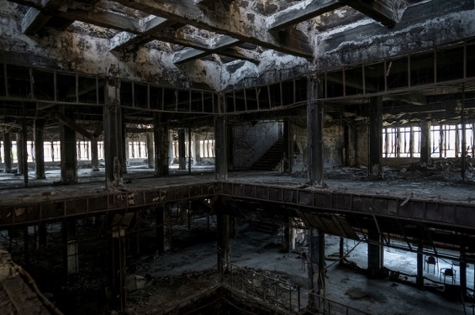
Interior of Central Library

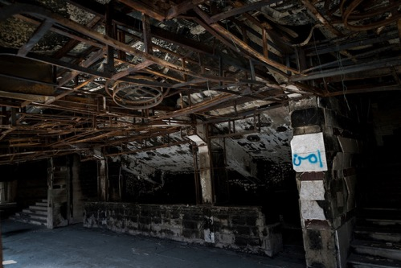
Interior of University Hall
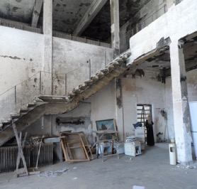
Damage to the Student Center Building
FFS relies on government counterparts – namely at Mosul University – to develop bills of quantities; however, in the name of efficientcy, FFS has been working through Q1 and Q2 to prepare the BoQs for a number of these nine sites, which would be available to KfW upon confirmation of the agreement.

Challenges:

The level of destruction and threat of IEDs and UXO, particularly in Mosul, challenge speedy assessment and implementation. While this does not prevent work or site visits, the need to carefully clear sites, at times more than once, mean that delays to project due to discovered explosive threats can be almost impossible to predict.

Secondly, it is important to remain cognasant that assessing damage to complex faciltities such as universities and hospitals is a highly complex operation. FFS relies on excellent partners, such as UNMAS, to clear sites and facilitate the access of engineers to fully assess the damage to the complex and develop realistic bills of quantities. However, in general, renovation of medical and educational facilities is a complex thing to do, involving decisions to reorient facilities towards particular areas of specialization and ensuring that provision is made for the most up-to-date forms of service delivery. The task, therefore, goes far beyond simply restoring what existed before. The development of BoQs, and their subsequent implementation, must always keep this in mind.

Agreement BMZ No. 201749944

Output 1 – Houses in Mosul are rehabilitated through local labor

Indicators:
  - # of individuals employed through the housing program
  - # of houses rehabilitated
  - # of direct beneficiaries
Targets:
  - 468 individuals employed through the housing program
  - 6,776 houses rehabilitated
  - 37,268 beneficiaries (# houses * average household size of 5.5 people)
Cumulative Progress as of Q1 2018:
  - 48 individuals employed
  - 0 houses rehabilitated
  - 0 beneficiaries

During Q1, FFS worked closely with the directorate of municipalities, UN-Habitat and the Shelter Cluster to collect data on return patterns and levels of damage to select the first neighborhoods for assessments. This is crucially important to plan ahead, set up a coordination structure, ensure the neediest areas are selected and ensure safeguards are in place to prevent the politicization of the choice of neighborhoods, resentment between neighbors and dealing with the homes of alleged “ISIL families.” It is important to reiterate; starting the programme takes more time than in other areas due to the complexities of operating in West Mosul: damage is widespread, returns are increasing but very slow, and multiple agencies are involved. Further, without careful planning and clear communication, housing support can inadvertently cause conflict amongst neighbors. As such, FFS has taken additional measures to ensure there is a clear, coordinated plan with fellow agencies and Mosul authorities.

Following the initial assessments with UN Habitat and the shelter cluster, the authorities and FFS identified – based on level damage, returnees, pull-factors, vulnerability, and presence of other agencies – 35 possible neighborhoods for intervention. The Ninewah Reconstruction Coordinator and FFS tentatively agreed to begin in 12 neighborhoods in West Mosul, and will expand once the initial 12 projects are initiated. FFS is targeting an estimated 10,000 houses for light repairs. The first 12 neighborhoods where rehabilitation will be undertaken have been preposed as follows:

Jadeda area:
- Wadi Hajar
- Nablus
- Al-Rahman (also called al-Amil)

Rabeea area:
- Al-Islah al-Ziraae
- Al-Rafidain (also called al-Nahrawan)
- Ibn Khaldoun (also called 17-Tamooz)

Ghizlani area:
- Bab al-Jadeed
- Al-Egedat
- Tawafa (part of Mahatta)

Old City :
- Myasa
- Al-Mansuriya
- Khazraj

Recruitment of housing engineers and social coordinators was ongoing during Q1 and 40 engineers and 8 social organizers were hired during Q2. The details of the engineers and social organizers recruited for the housing programme have been with the government vetting center in Baghdad for security clearance. This week the housing team leads met and started the GIS mapping of the neighborhoods and drafting the workplans for the first 12 neighborhoods that will be assessed. Finally, the Ninewah Reconstruction Coordinator, Municipalities Directorate, and Mayor’s Office agreed to form a steering committee to oversee the implementation strategy and provide overall guidance.

Challenges:
FFS has hired the teams and is ready to implement the projects; the only challenge is vetting of the hired staff, with currently rests with the Ministry of Interior. FFS Management has raised the issue with the Prime Minister’s Office for resolution, however, many government activities slowed down immediately prior to and after the elections held in early May. FFS anticipates the housing engineers to begin assessments in Q3.

Agreement BMZ No. 201618644

Overview: Agreement 2016-18-644 was a joint agreement between two programs in UNDP (Iraq Crisis Response and Resilience Program and the Funding Facility for Immediate Stabilization) and KfW for a total contribution of EUR 40 million. Activities for all four outputs are to be completed by 31 December 2019. The aim of the Agreement is to rehabilitate infrastructure and provide livelihoods opportunities in newly liberated areas by FFiS, and conduct resilience-building activities in the Kurdish Region of Iraq (KRI). This section below provides an overview of FFIS and ICRRP outputs.

The funding for FFIS infrastructure activities (FFIS Outputs 1) are nearly all expended or committed, well ahead of the December 2019 expiry. Additional activities for FFIS livelihoods activities (FFIS Output 2) will be updated and reported in the next progress report.

FFIS Output 1 – Rehabilitation of priority infrastructure in newly liberated areas

Indicators:
  - # of infrastructure rehabilitation projects undertaken in newly liberated areas
Targets:
  - 10 infrastructure rehabilitation projects undertaken in newly liberated areas (NB: no specific target was set as part of the Agreement other than indicative sectors and geographic areas)
Cumulative Progress as of Q1 2018:
  - 19 infrastructure rehabilitation projects undertaken in newly liberated areas of Anbar, Salah al-Din, Diyala, and Ninewah. 11 of these projects are complete.

Overall, KfW have supported 12 priority infrastructure projects; 11 in East Mosul and 2 in Fallujah, The primary focus of activities has been in the electricity sector, with 11 out of 13 projects being in the electricity sectory, and one project in the housing secor.

In East Mosul, eleven KfW funded electricity sector projects were undertaken. Of those eleven, four where completed during the reporting period, and seven are ongoing. These four 33/11KV substations required total rehabilitation by FFS due to the extent of their damage. In the meantime, FFS supplied and installed two mobile substations to support people in these neighborhoods until those works are completed. The names of the four completed projects 33/11KV are as follows:

- Renovation of 33/11 kV, 2*31.5 MVA ,Alarbajeya substation
- Rehabilitation of 33/11 kV, 2*31.5 MVA, Muthana Substation
- Renovation of 33/11 kV, 2*31.5 MVA Al Intisar substation
- Renovation of 33/11 kV, 2*31.5 MVA Besan substation

Local electricity authorities indicate that each of these substations supply power for 25,000-35,000 people, making these electricity projects extremely impactful with support to approximately 130,000 beneficiaries.

The details of the seven remaining ongoing projects are as follows:

- Renovation of Al Mujamah Sihy secondary electricity Sub Station (33/11) KVA (Al Majmuha) (99%), almost completed, awaiting competion of final details;
- Mujama Sihy (7%), casting of concrete for the foundation wall ongoing;
- Renovation of Baweza substationa 33/11 kV, (75%), with second transformer arrived;
- Renovation of AL Jazzair secondary electricity Sub Station (33/11) KVA, (30%) with transformer arrived to site and construction of concrete columns for the extension of the building ongoing;
- Hadba (90%) with transformer installed and energized; and
- Sumar (99%) almost complete and will be handed over to the end user beginning of Q3.

As above, local electricity authorities indicate that each of these substations supply power for 25,000-35,000 people, making these electricity projects extremely impactful with support to approximately 400,000 beneficiaries.

Completed:

In Bashir in southern Kirkuk, KfW funding supported the rehabilitation of one power station. The electrical substation had been significantly damaged by ISIL, but some level of electricity was being supplied to Bashir through the 11KV transmission line from Taza to Bashir with the installation of 15 transformers (250KVA, not funded by FFS). Worked was completed on the power station in April 2018. With its completion, 27,000 beneficiaries now have power. Moreover, also during the reporting period, FFS supplied electrical materials to the Bashir Electricity Department, include poles, cables, fittings, and other supplies that enable local authorities to rehabilitate parts of the electricity grid. The community is almost entirely Shia Turkmen, surrounded by 13 Sunni Arab villages. The impact that these two projects have on these communities, and on the Bashir electrical network, cannot be understated; 27,000 people or 4,500 families now have access to power.

KfW has also supported the housing sector through one project in Fallujah. The project was completed in early 2017, and provided housing repairs for 502 houses in Al Shuhadda II neighborhood of Fallujah. As in Ramadi, Mosul, and the Ninewah Plains, housing is a critical need in Fallujah, where thousands of homes were damaged and destroyed during the conflict. Fallujah was also the site of the first housing pilot program under FFS, following the Steering Committee’s approval of doing housing repairs in May 2017. In Fallujah, rehabilitation of housing (not KfW funded) is ongoing with results that have provided safe and serviceable accommodations for many thousands of residents. Working with local companies has continued to be the favoured approach. Following the award of contracts, the companies are under obligation to recruit local labor. This ensures that communities have access to dignified work and are integral to the rehabilitation process.

As previously reported, two projects were completed in the municipalities sector: one police station in Karma and one police station in Fallujah. Both projects were visited by FFS teams during the reporting period and the stations are in good repair and are being used for their intended function.

Ongoing:

KfW funding is supporting the implementation of one project in the water sector. In the devastated city of Baiji in Salah al-Din, there have been numerous stabilization challenges. Despite the city having been liberated in 2016, the area continues to have one of the slowest rates of return out of all liberated areas.

However, as of June 2018, IOM reported that there were 57,846 returns to Baiji, approximately 39% of its pre-ISIL population. People, therefore, are returning, in large part do to the restoration of services through sectorial project such as the KfW funded water sector project in Baiji. KfW is funding the supply and installation of the Baiji Central Water Station’s generator set, which will enable the facility to operate. FFS also completed rehabilitation works on the water station, but intermittent electricity meant that a generator was needed to ensure the most important public service is regularly available. The KfW funded generator was delivered on 13th March 2018 and installed on 16th March 2018. The Baiji water directorate is now waiting for certain cables to then test the generator and compete the project.

FFIS Output 2 – Jumpstarting the local economy and income generation such as cash for work

Indicators:
  - # of individuals benefiting from livelihoods activities such as cash for work in newly liberated areas, such as Anbar and Ninewah
Targets:
  - 2,500 individuals benefit from livelihoods activities such as cash for work in newly liberated areas, such as Anbar
  - 500 cash grants deliver in liberated areas such as Anbar and Ninewah
Cumulative Progress as of Q1 2018:
  - 60 individuals employed through cash for work opportunities in newly liberated areas (Fallujah)

Following the successful pilot in East Mosul (funded by KfW under Agreement -836), the model was introduced to Fallujah to repair desks for schools. Sixty participants are being employed for 50 working days to repair 5,000 desks. By the end of of the reporting period, the project was 100% completed. Additional livelihoods projects are in the works for the subsequent quarters of 2018.

Participants in cash for work are selected in partnership with municipal authorities, the mayor, and the Fallujah Education Department. The contracted partner is responsible for identifying the participants with the local authorities, and the FFS Livelihoods Team review the lists to ensure there is no duplication. As in other cash for work projects, the work is monitored by third-party monitors, FFS field staff, and Baghdad-based Livelihoods and Program Officers. Beneficiaries are paid on a weekly basis in the presence of the Baghdad-based team, and spot checks by phone and in person are conducted regularly to ensure beneficiaries are receiving their full pay. All documentation is reviewed and validated by the Livelihoods Team and Program Manager before proceeding to pay the vendor.

ICRRP Output 1: Greater socio-economic resilience created among the displaced populations (Syrian refuges and IDPs) and host communities

Activity 1.1 Socio-economic infrastructure constructed for sustainable and cost-effective provision of public services

Indicators:
  - # of infrastructure rehabilitated/constructed in the Kurdistan Region of Iraq (KRI)
Targets:
  - 4 infrastructure rehabilitated/constructed in the KRI as prioritized by local authorities and IDPs/refugees and their host communities
Progress in Q2 2018:
- 1 project was completed in the reporting period enhancing the delivery of health services in Shikan, Duhok.

In Duhok, a x-ray machine was delivered to Shikan tubercolosis hospital to increase the quality of critical health services provided by the only tuberculosis centre available in Duhok. The machine was installed in the reporting period and will benefit thousands of people living in Duhok, including internally displaced people (IDPs), Syrian refugees and members of the host community.

Activity 1.2: Greater economic resilience created for affected communities and IDPs/refugees through sustainable employment and local business/market creation

Indicators:
  - # of local market/value chain assessments conducted
  - # of micro, small and medium business opportunities for host communities and displaced populations created
  - # people benefitted from vocational trainings on marketable skills

Targets:
- 1 local market/value chain assessment to identify niche business/market demands and the support to micro, small and medium businesses/enterprises for youth and women
- 100 micro, small and medium business opportunities for host communities and displaced populations created
- 100 vulnerable people benefitted from vocational trainings for marketable skills

Progress in Q2 2018:

- An assessment on potential business development opportunities in the KRI was produced, focusing on cooperatives.

The assessment shows that cooperatives should be looked upon as a potentially very important livelihood-based intervention that could not only contribute to reducing the unemployment levels but also mainstream gender awareness in the development of durable livelihood solutions in the KRI.

Reflection is made on the required rules and regulations for cooperatives, which also supports the case for establishing cooperatives in the KRI, particularly for women’s cooperatives. Hence a road map for establishing women’s cooperatives is laid out and then actual business development opportunities for women’s cooperatives are proposed. Finally, the report concludes with a section on the potential of facilitating livelihood knowledge exchanges that could endorse and strengthen the case for establishing and developing cooperatives in the KRI.

Activity 1.3 Community-based dialogue platforms established for ensuring social cohesion and peaceful co-existence

Indicators:

- # consultations and dialogue sessions conducted for host communities and displaced population
- # of advocacy and community solidarity activities and/or events organized for host communities and displaced population
- # of monitoring tools developed to assess social tensions in Iraq at the sub-district levels

Targets:
  - 20 consultation and dialogue sessions conducted for host communities and displaced population through a participatory process
  - 10 advocacy and community solidarity activities and/or events organized
  - 1 monitoring tool developed to assess social tensions in Iraq at the sub-district levels and regularly collect data and analyze the status of social tensions

Progress in Q2 2018:

All activities were completed before Q2 2018, as mentioned in previous reports.
- Community Centre in Arbat, Sulaymaniyah, providing psychosocial and legal support as well as community-based activities to improve social cohesion amongst people from different ethnic and religious backgrounds. The Centre is run by international and national non-governmental organizations under the auspices of the Directorate of Art and Culture of the Ministry of Youth and Culture.
- Promoting community cohesion in Duhok through social cohesion activities/capacity building workshops in the following areas: peace through art, youth camping, awareness raising on coexistence and peace-building, and results-based management. Activities targeted youth from different religious and ethnic groups such as Christians, Yezidis, Muslims as well as Iraqi Kurds and Arabs, Syrian Kurds and Arabs.

ICRRP Output 2: Resilient socio-economic conditions created to rebuilt people’s lives and communities in the Newly Liberated Areas (NLAs)

Activity Result 2.1: Community-based infrastructures rehabilitated for restoring basic services in the return areas

Indicators:
  - # of infrastructure rehabilitated/constructed in the NLAs

Targets:
- 25 infrastructure rehabilitated/constructed in the NLAs
Progress in Q2 2018:

- Construction/rehabilitation of 18 infrastructure is ongoing or completed in the reporting period in Diyala and Ninewah. All projects were identified in close consultation with Government officials and community leaders.
More specifically:
- 4 water projects were completed in Diyala
- 2 water projects are ongoing in Diyala
- 1 housing project in ongoing in Ninewah
- Construction of 11 schools started in the reporting period in Diyala

In Diyala, infrastructure have suffered severe damage under the Islamic State of Iraq and the Levant (ISIL) control and during the ensuing conflict to liberate the cities. Ensuring the provision of basic services, as water, roads, and education is key to restore the life of people in the aftermath of the conflict and encourage sustainable returns.

In the reporting period, ICRRP has supported local authorities to construct/rehabilitate six water projects and initiate the construction work for 11 new schools benefiting over 70,000 returnees, refugees, IDPs and host community members. Moreover, the rehabilitation of six roads in Al Muqdadiya, Baladrouz, and Baquba city is expected to start in mid-July 2018.

In addition, UNDP has identified several other projects and are assessing the feasibility and budget availability of these.

Water
The following four water projects were completed in the reporting period:
- Rehabilitation of three water complexes in Al Muqdadiya District
The three water complexes were damaged due to the ISIL’s crisis and the liberation operations in the area. The work included rehabilitation/provision of water pumps, water tanks, connection pipes as well as electrical work. The water plant is providing safe water to approximately 12,000 people living in Al Muqdadiya, Barkaniya , Al Anbakya and Al Bori sub-districts.

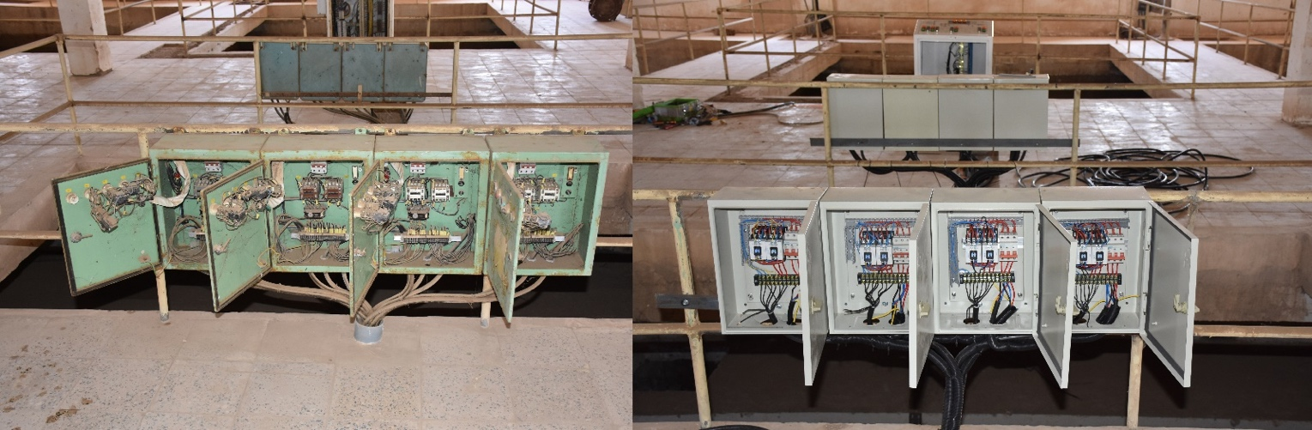
Before and after electrical work at water complex in Al Muqdadiya District

- Rehabilitation of Al Saad Al Adim water complex and desalination plant in Al Udhaim District
The water plant is now restored to its full capacity providing safe water to approximately 35,000 people. The rehabilitation responded to a need for improved delivery of water living in Al Udhaim and surrounding villages.

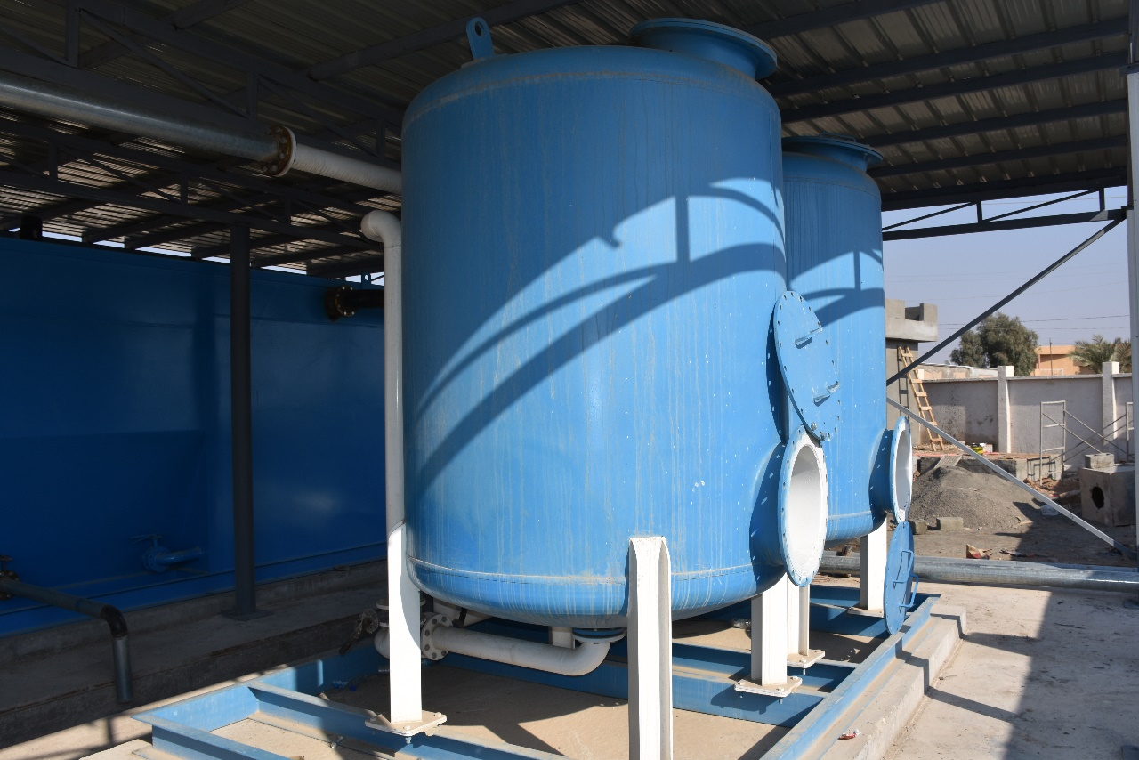
Al Saad Al Adim water project

The following two water projects are ongoing in the reporting period:
- Rehabilitation of central water plant in Zanbour, Al Khalis District
Rehabilitation work is 75% complete. Once the work is finalized, over 12,000 people will have improved access to safe water.

- Rehabilitation of the water complex in Al Sa'adyat Al Shat, Al Khalis District
Rehabilitation work is 50% complete. Once the work is finalized, over 8,000 people will have improved access to safe water.
Schools

UNDP is supporting the Diyala Governorate to build 11 schools, including sport facilities, to respond to urgent demand for educational services in the following districts: Al Muqdadiya (four schools), Al Khalis (three schools), Baladrouz (two schools), Khanaqueen (one school) and Kanaan (one school). These projects support the Directorate of Education efforts to improve learning opportunities and to boost social well-being for youth in Diyala. In addition to ensuring that children and young people can continue their studies, opening schools is an important component of rebuilding societies in the aftermath of conflict. The implementation of these projects started in mid-April 2018 and once completed, will benefit over 7,000 female and male students.

Roads

Construction/rehabilitation of six roads, including pavement, is expected to start in mid-July 2018 to facilitate movements between the targeted districts and surrounding areas, which have been neglected by the local authorities due to scarce financial resources:

- Pavement of several internal roads (3 km in total) in sector 311, Hay Al-Tahrir Quarter, Baquba District
- Construction of road (700 m) between Al-Jme'a street and Imam Askar Village, Al Maqdadiya District
- Construction of road (800 m) between Burgainiya and Wajihiya villages, Al Maqdadiya District
- Construction of road (500 m) Al Bawaba, Baladrouz District
- Construction road (250 m) between Abdulla Al Khadhim and Imam Askar, Baladrouz District
- Renovation and pavement of Al Hassan Road (4.1 km), Baquba District.

Sinjar, in Ninewah Governorate, home to the minority Yazidi community, has experienced severe destruction and an almost complete displacement of its population. Targeted destruction of houses during hostilities not only affects the right to adequate housing of affected people, but also impedes their safe and voluntary return to their region of origin.

Housing

In response to the critical situation of the housing sector in Ninewah and to contribute towards sustainable return of the Yazidi community in their area of origin, ICRRP and UN Habitat, in partnership with the Ninewah Governor’s Office, assessed 108 damaged houses for rehabilitation. This completed the assessment component of the project with a total of 1,039 houses assessed across Sinjar District. The rehabilitation of 464 housing units is ongoing. The project adopted a community-driven delivery scheme, including partnerships with local private contractors and the direct engagement of community members in reconstruction efforts in line with the principles of Area Based Recovery Approach.

Activity 2.2: Emergency livelihood opportunities created with revitalization of local economy

Indicators:
  - Assessments and pilot initiatives developed for local economic revitalization and community financing measures
  - # people provided with immediate income and employment opportunities through cash for work
  - # of returnees provided with small grants support

Targets:
  - Assessments and pilot initiatives developed for local economic revitalization and community financing measures, such as micro-insurance and savings
  - Immediate income and employment opportunities provided to 1,200 people through cash for work
  - Small grants provided to 120 returnees to restart their businesses
Progress in Q2 2018:

Activities will be launched in Q3 2018.

Activity 2.3 Social Cohesion created through peace-building and reconciliation dialogues with conflict prevention support

Indicators:
- # of consultation and dialogue sessions conducted for host communities and IDPs
- # of peace and community solidarity activities and/or events as well as peace building skill sessions organized
- # of monitoring tool developed to assess social tensions in Iraq at the sub-district level

Targets:
- 25 consultation and dialogue sessions conducted for host communities and IDPs through a participatory process
- 25 peace and community solidarity activities and/or events and six peace building skill sessions organized
- 2 monitoring developed tools to assess social tensions in Iraq at the sub-district level and regularly collect data and analyze the status of social tensions

Progress in Q2 2018:
- 5 dialogue sessions were conducted benefiting approximately 84 people (53% women) in Jalawla and Khanaqueen, in Diyala Governorate.
- 9 community-based activities were conducted by peace actors in three community centres supported by ICRRP benefiting over 240 people (39% women).
- A baseline survey on the social stability context in Diyala Governorate is being finalized, focusing on three locations: Jalawla, Baquba and Khanaqeen.

The ethnic, religious and tribal distribution of Diyala is very diverse. Arabs, Kurds, Turkmens, Assyrians, Chaldeans, Syriacs, Sabiah and Jewish families live in the governorate. Regarding the religious makeup, the majority are Muslims living alongside a number of Christian, Jewish, Sabiah and Kakaie families.

In partnership with Al Mesalla organization, the capacity of community peace actors, both members of host communities and IDPS, is being strengthened to manage conflicts, promote peacebuilding and coexistence among different groups.

More specifically, five dialogue sessions were conducted benefiting approximately 84 people (53% women) from different ethnic and religious background. One session was held in Jalawla focusing on the partnership between peace actors and local authorities while four sessions were held in in Khanaqeen discussing women’s empowerment, partnership between peace actors and local authorities as well as the role of the media in peacebuilding.

Nine community-based activities were conducted by peace actors in three community centres supported by ICRRP benefiting over 240 people (39% women). Three events were conducted in Khanaqeen bringing together youth from different religious an ethnic background through computer and media trainings. In Jalawla, two recreational activities took place (planting tree in a park and chess competition. Four activities took place in Baquba which involved recreational activities, such as a trip to Baghdad engaging youth.

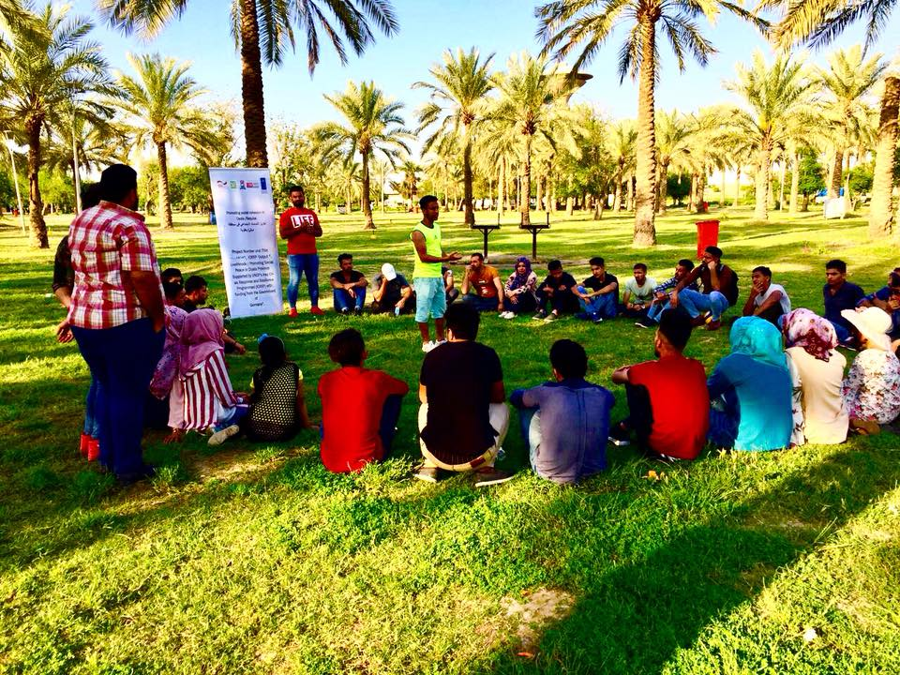
“It was more than a trip; it was a journey to explore mutual respect and harmony amongst different religious and ethnics groups!” feedback from a participant in the community based activity organized in Baghdad.

A baseline survey on the social stability context in Diyala Governorate is being finalized, focusing on three locations: Jalawla, Baquba and Khanaqeen. The study is based on insights from over 300 people, including activists, state and non-state security actors, tribal and religious leaders, and IDPs.

The findings will provide insights on social tensions in Diyala as they are perceived by the local population and will offer recommendations for promoting coexistence involving the following groups: local governments, community leaders, civil society, Federal Government and Kurdistan Regional Government as well as the international community.

Once finalized, the study will be available in English and Arabic and disseminated to stakeholders.

Interim (Cumulative) Financial Summary

Agreement | Total Amount  (Euro) | Estimated Budget  (USD) | Received So far  (USD) | Committed (USD) | Expenditure (USD) | Total Utilized  (USD)
2016-18644 | 29,500,000 | 33,146,068 | 24,923,057 | 8,917,664.18 | 8,098,120.10 | 17,015,784.28
Total | 29,500,000 | 33,146,068 | 24,923,057 | 8,917,664.18 | 8,098,120.10 | 17,015,784.28

Annex I: FFS Project Details

Agreement No. 2017-40-836 – Cash for Work in Mosul
Mosul City, Ninewah Governorate
Location | Project name | Status | Beneficiaries | Cost*
West Mosul | West Mosul General Hospital | Completed | 65 | $ 49,288.00
West Mosul | Al-Jadeeda | Completed | 211 | $ 431,700.00
West Mosul | Ninewah University | Completed | 44 | $ 35,656.00
West Mosul | Clean up Soq Al Mosul shehk Abo Al Ola 2 Neighborhoods in the west Mosul | Completed | 158 | $ 298,801.40
West Mosul | Clean up of Naby Gargeas and Shekh Abo A-Ola 3 Neighborhoods in the old city -West Mosul | Completed | 158 | $ 295,695.00
West Mosul | Al -Ghizlani Clean up Project -West Mosul, Ninawa Governorate Lot 1-Al-Jawasaq & Al-Tayaran Neighborhoods | Completed | 315 | $ 556,830.00
West Mosul | Al -Ghizlani Clean up Project -West Mosul,Ninawa Governorate Lot 2-Dandan, AlDawasa&Naby Sheet Neighborehoods | Ongoing | 369 | $ 646,319.00
West Mosul | Al -Ghizlani Clean up Project -West Mosul,Ninawa Governorate Lot 3-Al Okaidat& Bab Agaded Neighborhoods | Completed | 315 | $ 556,970.00
West Mosul | Al-Rabee, Lot 1: Misherfa 1, Misherfa 2, 17 Tamuz , 30 Tamuz, Al Eqtisadiean | Ongoing | 316 | $ 700,860.00
West Mosul | Al-Rabee, Lot 4: Hay Al Maamel, Yarmok, Nahrawan | Completed | 316 | $ 743,635.00
West Mosul | Clean Up Qatheb AlBan And Meshahda Neighborhoods/ West Mosul | Ongoing | 158 | $ 315,966.00
West Mosul | Clean Up Khatoniya And Ahmadeya Neighborhoods - West Mosul | Ongoing | 157 | $ 289,594.00
West Mosul | Clean-up Project of Hospital Complex Lot 1 (Al-Batool maternity hospital, Infertility center, X-ray institute, Burns Unit) | Completed | 210 | $ 195,268.00
West Mosul | Clean-up Project of Hospital Complex Lot 2 (Blood Bank Building, Internal Streets and all courtyards) | Completed | 209 | $ 209,115.75
East Mosul | Al-Zuhoor (Lot 3) | Completed | 320 | $ 874,972.00
East Mosul | Al-Zuhoor (Lot 4) | Completed | 320 | $ 874,972.00
East Mosul | Al-Zuhoor (Lot 5) | Completed | 320 | $ 790,382.00
East Mosul | Nerkal | Completed | 727 | $ 1,215,524.00
East Mosul | Mosul Technical College and Technical Institute clean up project Ninawa Governorate Iraq | Completed | 265 | $ 444,322.00
East Mosul | Clean-up of Mosul University/East Mosul | Ongoing | 160 | $ 516,978.00
East Mosul | Cash For Work - Repairs of Kokjely Schools Desks | Completed | 22 | $ 14,912.00
Total number of projects: 21 |  | Total | 5,135 | $ 10,057,760.15

*Costs for projects being implemented are subject to change. During implementation, variation orders are sometimes issued and contracts amended. These figures do not constitute official financial reporting.

Agreement No. 2017-18-626 - FFES
Mosul, Ninewah Governorate; Ramadi, Anbar Governorate
Status | Project Name | Beneficiaries | Cost
Tendering | Ramadi Maternity Hospital rehabilitation | 400,000 | 0
Tendering | Medical equipment for Maternity Hospital |  | 0
BOQ | Mosul University Central Library | 40,000 | 0
Tendering | Mosul University substation (Al Jameaa) |  | 0
TBD | Additional Mosul University projects TBD
Total FFES projects in Mosul and Ramadi: 4 projects |  | Total estimated beneficiaries: 0 | Total cost: 0

Agreement No. 2017-49-944 – Housing
Mosul, Ninewah Governorate
Status | Project Name | Beneficiaries | Cost
Development | Housing rehabilitation | N/A | N/A
Total housing projects in Mosul: 0 projects |  | Total estimated beneficiaries: 0 | Total cost: 0

Agreement No. 2016-18-644 – Support to Newly Liberated Areas, FFS
Ninewah, Anbar, Kirkuk, Salah al-Din Governorates
City | Project name | Status | Beneficiaries | Cost
East Mosul | Supply and Install of 2 Mobile Sub-Station (25 MVA) for Ninewah, Mosul-East | Implementing | 70000 | $1,840,000
East Mosul | Renovation of Al Mujamah Sihy secondary electricity Sub Station (33/11) KVA | Implementing | 35000 | $1,129,340
East Mosul | Renovation of 33/11 kV, 2*31.5 MVA Al Qudis area substation | Implementing | 35000 | $42,130
East Mosul | Renovation of 33/11 kV, 2*31.5 MVA Baweza substationa | Implementing | 35000 | $1,206,792
East Mosul | Renovation of 33/11 kV, 2*31.5 MVA ,Alarbajeya substation | Completed | 25000 | $49,364
East Mosul | Rehabilitation of Muthana Substation (33/11 KV) in Mosul-East | Completed | 35000 | $1,004,340
East Mosul | Renovation of AL Jazzair secondary electricity Sub Station (33/11) KVA | Implementing | 35000 | $1,108,855
East Mosul | Renovation of 33/11 kV, 2*31.5 MVA Al Intisar substation | Completed | 35000 | $30,758
East Mosul | Renovation of 33/11 kV, 2*31.5 MVA Besan substation | Completed | 35000 | $13,233
East Mosul | Rehabilitation of Hadbaa Substation (33/11 KV) in Mosul-East | Implementing | 25000 | $671,274
East Mosul | Rehabilitation of Sumer Substation (33/11 KV) in Mosul-East | Implementing | 35000 | $88,100
Fallujah | Rehabilitation of Damaged Desks for Fallujah Schools in Fallujah lot 2 | Completed | 60 | $109,385
Bashir | Reconstruction of Bashir Power Station Building-Taza District. | Completed | 27000 | $349,225
Bashiqa | Bashiqa PHC | Completed | 12000 | 11180
Baiji | Generator set supply and installation for Baiji Water Station | Implementing | 200000 | $242,850
Ramadi | Rehabilitation of secondary electrical power station no. 2 close to the computer college; University of Anbar, Ramadi | Completed | 4500 | $320,110
Fallujah | Rehabilitation of Community Police Station in Fallujah | Completed | 4000 | $573,829
Karma | KARMA POLICE STATION | Completed | 4000 | $562,661
Fallujah | Renovation Housing Works of 502 units in Al- Shuhada II, Fallujah | Completed | 2761 | $908,569
Total |  |  | 65,4321 | $10,261,995

*Costs for projects being implemented are subject to change. During implementation, variation orders are sometimes issued and contracts amended. These figures do not constitute official financial reporting.

The Q1-2018 Report also included the budget still in planning phases.
The Q1 report tentatively reported that 29 projects were identified. However, during Q2, following a further review of the project, it was agreed that 28 Projects would be supported on a priority basis through this contribution.
The Q1-2018 Report also included the budget still in planning phases.

